027_Abhishek_Ojha

DESIGN ANALYSIS AND ALGORITHM

PRACTICAL NO 3

**Experiment No – 3 Date of Experiment : 14th September 2021**

**Program : -** Write a program on Strassen’s algorithm for matrix multiplication and analyze its complexity

**Example :-**

**Matrix Multiplication 3x3**

**Input :-**

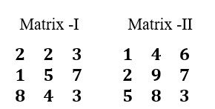

**Algorithm :-**

for i = 1 to p do for j = 1 to r do Z[i,j] := 0

for k = 1 to q do

Z[i,j] := Z[i,j] + X[i,k] × Y[k,j]

**Fig :-**

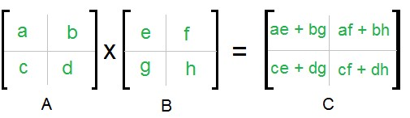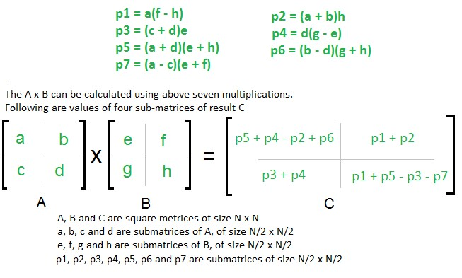

**Program : -**

/**

 ** Java Program to Implement Strassen Algorithm

 **/

import java.util.Scanner;

/** Class Strassen **/

public *class* Strassen

{

    /** Function to multiply matrices **/

    public int[][] multiply(int[][] A, int[][] B)

    {

*int* n = A.length;

        int[][] R = new int[n][n];

        /** base case **/

        if (n == 1)

            R[0][0] = A[0][0] * B[0][0];

        else

        {

            int[][] A11 = new int[n/2][n/2];

            int[][] A12 = new int[n/2][n/2];

            int[][] A21 = new int[n/2][n/2];

            int[][] A22 = new int[n/2][n/2];

            int[][] B11 = new int[n/2][n/2];

            int[][] B12 = new int[n/2][n/2];

            int[][] B21 = new int[n/2][n/2];

            int[][] B22 = new int[n/2][n/2];

            /** Dividing matrix A into 4 halves **/

            split(A, A11, 0 , 0);

            split(A, A12, 0 , n/2);

            split(A, A21, n/2, 0);

            split(A, A22, n/2, n/2);

            /** Dividing matrix B into 4 halves **/

            split(B, B11, 0 , 0);

            split(B, B12, 0 , n/2);

            split(B, B21, n/2, 0);

            split(B, B22, n/2, n/2);

            /**

              M1 = (A11 + A22)(B11 + B22)

              M2 = (A21 + A22) B11

              M3 = A11 (B12 - B22)

              M4 = A22 (B21 - B11)

              M5 = (A11 + A12) B22

              M6 = (A21 - A11) (B11 + B12)

              M7 = (A12 - A22) (B21 + B22)

            **/

            int [][] M1 = multiply(add(A11, A22), add(B11, B22));

            int [][] M2 = multiply(add(A21, A22), B11);

            int [][] M3 = multiply(A11, sub(B12, B22));

            int [][] M4 = multiply(A22, sub(B21, B11));

            int [][] M5 = multiply(add(A11, A12), B22);

            int [][] M6 = multiply(sub(A21, A11), add(B11, B12));

            int [][] M7 = multiply(sub(A12, A22), add(B21, B22));

            /**

              C11 = M1 + M4 - M5 + M7

              C12 = M3 + M5

              C21 = M2 + M4

              C22 = M1 - M2 + M3 + M6

            **/

            int [][] C11 = add(sub(add(M1, M4), M5), M7);

            int [][] C12 = add(M3, M5);

            int [][] C21 = add(M2, M4);

            int [][] C22 = add(sub(add(M1, M3), M2), M6);

            /** join 4 halves into one result matrix **/

            join(C11, R, 0 , 0);

            join(C12, R, 0 , n/2);

            join(C21, R, n/2, 0);

            join(C22, R, n/2, n/2);

        }

        /** return result **/

        return R;

    }

    /** Funtion to sub two matrices **/

    public int[][] sub(int[][] A, int[][] B)

    {

*int* n = A.length;

        int[][] C = new int[n][n];

        for (*int* i = 0; i < n; i*++*)

            for (*int* j = 0; j < n; j*++*)

                C[i][j] = A[i][j] - B[i][j];

        return C;

    }

    /** Funtion to add two matrices **/

    public int[][] add(int[][] A, int[][] B)

    {

*int* n = A.length;

        int[][] C = new int[n][n];

        for (*int* i = 0; i < n; i*++*)

            for (*int* j = 0; j < n; j*++*)

                C[i][j] = A[i][j] + B[i][j];

        return C;

    }

    /** Funtion to split parent matrix into child matrices **/

    public void split(int[][] P, int[][] C, *int* iB, *int* jB)

    {

        for(*int* i1 = 0, i2 = iB; i1 < C.length; i1*++*, i2*++*)

            for(*int* j1 = 0, j2 = jB; j1 < C.length; j1*++*, j2*++*)

                C[i1][j1] = P[i2][j2];

    }

    /** Funtion to join child matrices intp parent matrix **/

    public void join(int[][] C, int[][] P, *int* iB, *int* jB)

    {

        for(*int* i1 = 0, i2 = iB; i1 < C.length; i1*++*, i2*++*)

            for(*int* j1 = 0, j2 = jB; j1 < C.length; j1*++*, j2*++*)

                P[i2][j2] = C[i1][j1];

    }

    /** Main function **/

    public static void main (String[] args)

    {

        Scanner scan = new Scanner(System.in);

        System.out.println("Strassen Multiplication Algorithm Test\n");

        /** Make an *object* of Strassen class **/

        Strassen s = new Strassen();

        System.out.println("Enter order n :");

*int* N = scan.nextInt();

        /** Accept two *2d* matrices **/

        System.out.println("Enter N order matrix 1\n");

        int[][] A = new int[N][N];

        for (*int* i = 0; i < N; i*++*)

            for (*int* j = 0; j < N; j*++*)

                A[i][j] = scan.nextInt();

        System.out.println("Enter N order matrix 2\n");

        int[][] B = new int[N][N];

        for (*int* i = 0; i < N; i*++*)

            for (*int* j = 0; j < N; j*++*)

                B[i][j] = scan.nextInt();

        int[][] C = s.multiply(A, B);

        System.out.println("\nProduct of matrices A and  B : ");

        for (*int* i = 0; i < N; i*++*)

        {

            for (*int* j = 0; j < N; j*++*)

                System.out.print(C[i][j] +" ");

            System.out.println();

        }

    }

}

**Practical Implementation of Strassen’s Algorithm** :-

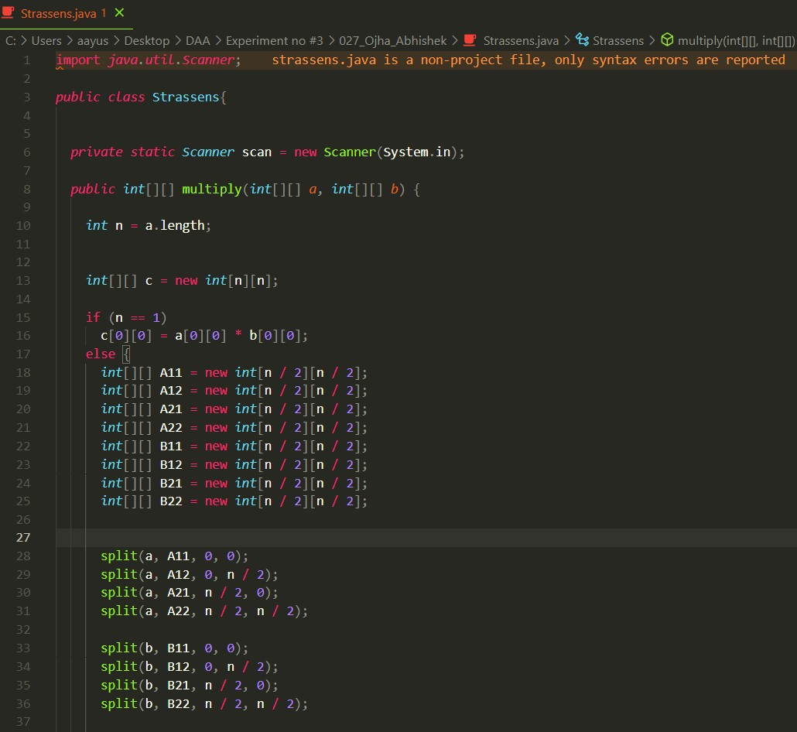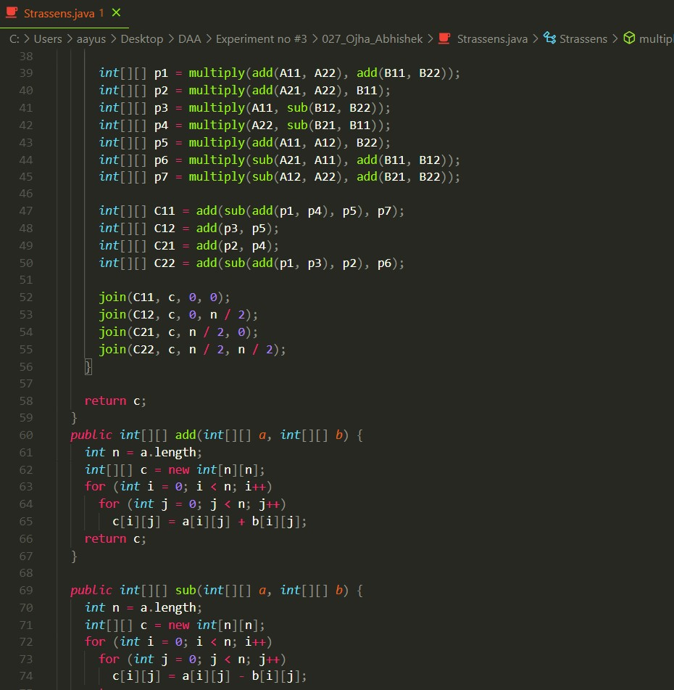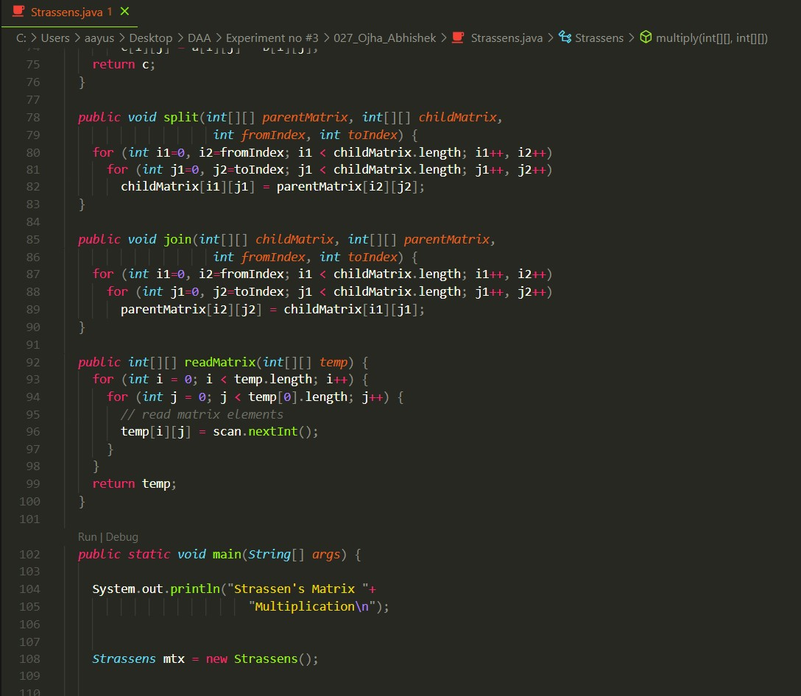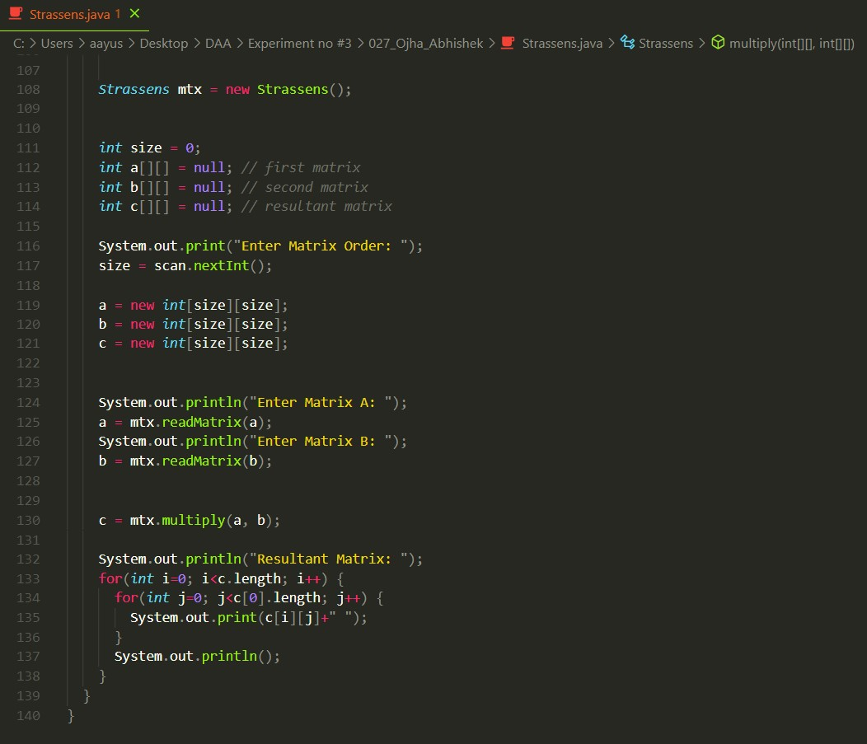

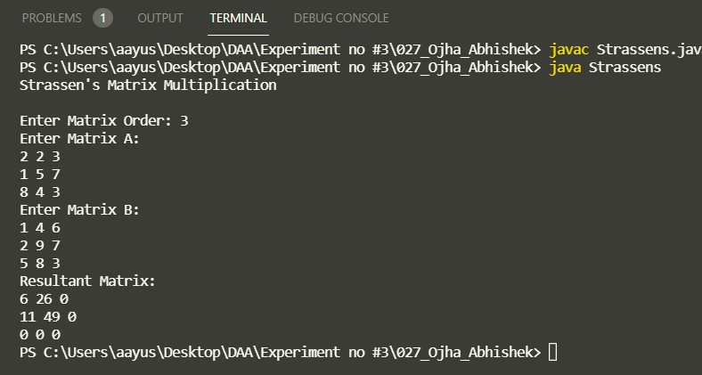**Output**

**Analysis :**

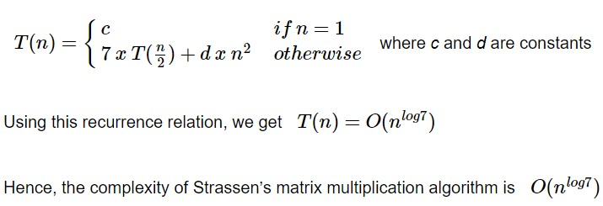

**Conclusion :**

integer operations take *O(1)* time. There are three for loops in this algorithm and one is nested in other. Hence, the algorithm takes *O(n3)* time to execute.